|  |  |  |
| --- | --- | --- |
| **LAB101 Assignment** | **Type:** | **Short Assignment** |
| **Code:** | **C.S.P0020** |
| **LOC:** | **84** |
| **Slot(s):** | **2** |

**Title**

Grocery Store Database.

**Background Context**

In this assignment you are to write a program that will maintain a small grocery database (i.e., array of structures).

**Program Specifications**

Your program should first ask the user the name of the text file that contains the data for the database. Then, it should open the file and read its contents into an array of item structures. (The maximum size of the array will be 10) After the file is opened and the contents are read into the array, close the file and display the following menu:

1. Add new item
2. Delete item
3. Change the cost of an item
4. Search for item
5. Display inventory details
6. Quit

Each menu choice should invoke an appropriate function to perform the selected menu item/task. Your program must display the menu after each task and wait for the user to select another option until the user chooses to quit the program.

***Function details:***

1. Menu Option 1: Your program should prompt the user for the item’s id number, name, cost and category. The new item must be appended to the end of the database (in memory). Do not allow duplicate items (names nor id) in the database. An item is a duplicate if it's id number matches that of another product already in the database, or if its name is identical to the name of another product in the database. If the user attempts to add a duplicate item, do not add it and print out an error message stating that the item was not added since it was already in stock.
2. Menu Option 2: Your program should prompt the user for the item’s id number. If the id number is found in the database, your program should delete that element from the array (of structures) by replacing it with the last record in the database. If the id number is not found, your program should notify the user.
3. Menu Option 3: Your program should prompt the user to enter an existing id number. Once the user enters the id number, your program should get the new value for the item’s cost, and update the database accordingly.
4. Menu Option 4: Your program should prompt the user to enter an item name. If the item name is found in the database, your program should display the contents of that item. Otherwise, it will notify the user that the item is not found in the database.
5. Menu Option 5: Your program should display the contents of the entire database preferably in tabular/spreadsheet format.

***Expectation of User interface:***

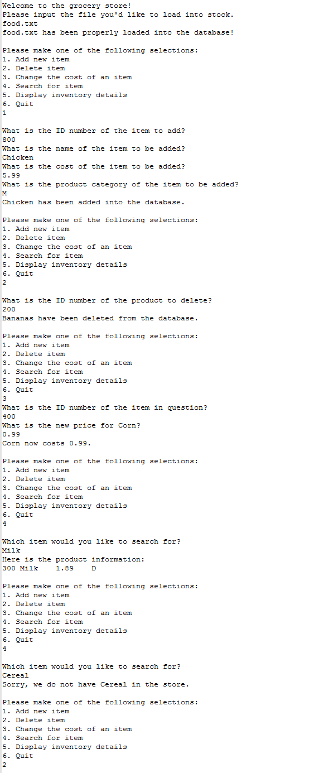

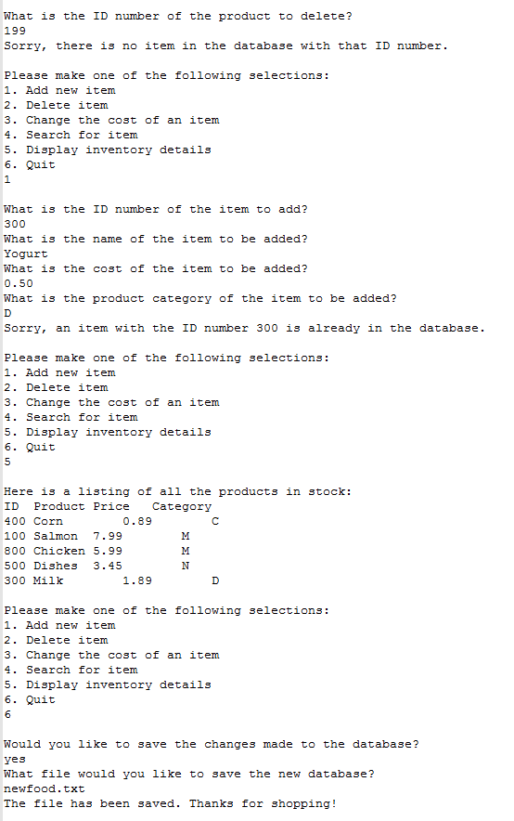

**Guidelines**

For testing your program, you should create a data file of input. The data file should be a text file (i.e., you can create it using pico, notepad, etc.). The text file should include one record on each line, with spaces between each field. On each line, the universal product identifier is followed by the item name, the price of the item and the product category.

Here are the contents of a sample file, food.txt:

*400 Corn 0.89 C*

*100 Salmon 7.99 M*

*200 Bananas 1.58 P*

*500 Dishes 3.45 N*

*300 Milk 1.89 D*

Of course, your program should continue reading records (line by line) until it detects the EOF. Once the data are read into the database (array of structures) in memory, all changes should be done in the array. When the user chooses to quit the program, if the “save flag” is true, your program should give the user the option of saving the changes. If the user wishes to save the changes, your program should prompt the user to give a new file name. Your program must not accept the same file name as the original data file. The changes must be written to a new/different file.